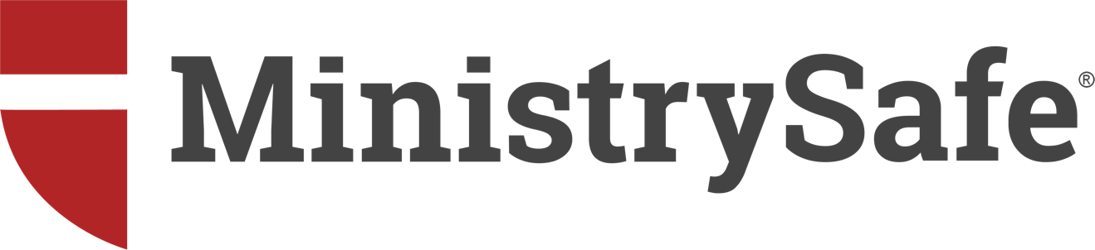

FACILITIES USE FIRE DRILL
Sexual Abuse Risk and Third-Party Use of Facilities

By Gregory Love & Kimberlee Norris
Date: March 1, 2022

BOY SCOUTS SETTLEMENT FUND EXCEEDS $2.6 BILLION
Not every organization has chartered or hosted a Boy Scout Troop, but every organization with physical facilities must learn the lessons stemming from this massive child sexual abuse settlement. Third-party use of facilities can lead to liability related to various types of risk – including child sexual abuse.

“But no one on our staff engaged in abusive conduct,” said one executive director of a major midwestern organization. Unfortunately, direct staff interaction isn’t required for third-party liability to manifest. Thousands of churches that charted Boy Scout troops are learning that the behavior of third parties can give rise to exposure with an enormous cost. Most of these churches never saw it coming – yet the risk was foreseeable … and therefore preventable.

There are obvious lessons to be learned– beyond the astonishing number of victims, devastating damage to children and the cost of resolving the resulting claims. Thousands of young men and their families expected a life-enriching experience from scouting, and experienced instead the ravaging impact of child sexual abuse.

Less obvious are the takeaways related to sexual abuse litigation and use of facilities. As sexual abuse attorneys and child protection experts, we have counseled thousands of child-serving organizations regarding sexual abuse risk and third-party liability: risk stemming from the behavior of another, occurring on your organization’s property or while utilizing your facilities.

This article addresses child sexual abuse risk arising from third party use of facilities, and introduces a pathway to quantify this risk utilizing the Facilities Use Fire Drill; this article will conclude with analysis and forms helpful in moving forward in allowing facilities use by a third party.

What is third-party liability?
How can a Facilities Use Fire Drill be useful in identifying risk?
When and how should an organization make its facilities available to third parties?
How far should a hosting organization go to verify Safety Controls?

These questions are best answered with a better understanding of the fact pattern leading up to the BSA settlements.

BOY SCOUTS: WHAT HAPPENED?
On May 18, 2020 the Boy Scouts of America filed for bankruptcy protection, largely in response to mounting sexual abuse allegations and civil lawsuits. On July 1, 2021 virtually every major media outlet announced a settlement of $850,000,000.00, meant to resolve more than 60,000 sexual abuse claimants suing Boy Scouts of America. The initial settlement was not the end of the matter; churches, denominations and their insurers then became the focus of civil lawsuits meant to force additional contributions to the settlement fund in order to resolve the claims.

Churches and Boy Scout Troops
For decades, local churches have chartered Boy Scout Troops. Church leaders have seen scouting as a way of enriching the lives of youth and positively impacting the community. In many cases, the troop began meeting regularly in the church building after the Charter Agreement was signed. Not much oversight or involvement by the church was necessary – until an abuse allegation was followed by a civil lawsuit.

Understanding Sexual Abuse Litigation
The primary redress available through civil litigation is monetary damages. When a sexual abuse victim seeks legal counsel, the focus is rarely on the perpetrator, who lacks deep pockets: the ability to satisfy or pay a monetary judgment. Plaintiff’s attorneys who represent abuse survivors rarely sue the perpetrator. The focus of the plaintiff’s counsel is any related entities – no matter how tenuous the relationship – to the occurrence of abuse, particularly when an entity appears to have assets or insurance. In BSA claims, plaintiffs’ counsel focused on chartering churches (and their insurers) as an additional source of funds.

When the number of allegations against the Boy Scouts of America reached into the thousands, BSA leadership chose bankruptcy in order to navigate the sheer volume of claims and anticipated funds necessary to resolve them. The chartering organizations (primarily churches and denominations) watched these developments closely, strongly encouraging BSA to resolve the claims in such a way that the chartering churches would be released from liability in the contemplated settlement agreement.

Instead, when BSA leaders signed the settlement agreement in July 2021, BSA did NOT include the churches as released parties. In BSA claims, plaintiffs’ counsel shifted focus to the chartering churches (and their insurers) as an additional source of funds.

The Church of Jesus Christ of Latter Day Saints (LDS) was the single largest sponsor of Boy Scout troops until 2020. On September 15, 2021, LDS agreed to pay $250 million into the settlement fund under a separate agreement.

As of 2020, over 5,000 Methodist churches had chartered a Boy Scout Troop. Like the LDS, Methodist churches were NOT released by the BSA settlement agreement. On December 21, 2021 negotiators for the United Methodist Church agreed to pay $30 million into the Boy Scouts settlement fund to settle claims aimed at local United Methodist churches.

Other denominations and churches have contributed substantial amounts to the settlement fund or are currently negotiating a contribution in order to be released from liability.

As of this writing, the compensation fund – an aggregate of all monies paid in by BSA, its insurers and chartering organizations – totals more than $2.6 billion: the largest aggregate sexual abuse settlement in United States history.

THIRD-PARTY LIABILITY
In its simplest form, third-party liability occurs when an organization is held responsible for the bad acts of another individual or entity. To be clear: an organization need not charter a troop to be named in a lawsuit; the nexus can be as tenuous as simply allowing an individual or entity to use the organization’s facilities. This use might include, for instance, use of a gym, playground, camp, conference area, classroom, parking lot, sport court or sports field.

How is third-party liability supported?
Plaintiffs’ counsel utilize various theories of liability to access defendants perceived as deep pockets (or source of funding), including Negligent Provision of Use, Negligent Supervision of Use and Negligent Failure to Require Safety Provisions. From the plaintiff’s counsel’s standpoint, the analysis starts with this reality: the organization has control over its property. The organization can and should perform reasonable due diligence concerning who or what is permitted on its property, with attendant foreseeable risks. If a program or activity will involve children, the organization has the right to require certain child protection measures as a condition of use.

Most organizations are generous and give freely – providing use of facilities with an open hand. Many organizations have lost track of how many individuals or entities are using the organization’s facilities, or simply do not know. Organizations must balance inherent generosity with an understanding of risk.

In general, insurance carriers clearly understand third-party risk related to child sexual abuse; many are now requiring organizations to identify all third-party use before providing coverage – or simply excluding coverage for all third-party use.

Organizations must know who is using its facilities, what programming and activities are provided, and whether effective child protection elements are in place. In short, organizations must perform a Facilities Use Fire Drill.

FACILITIES USE FIRE DRILL
In classrooms across the country, school administrators lead faculty and students through mock disasters (fires, shootings, bomb threats, tornados, etc.) to ensure the existence of sound safety plans, communicate expectations to all involved, and determine any necessary changes or improvements.

A failure to drill potential disasters can lead to catastrophic results, generally with little or no warning. In the midst of a crisis, it’s too late to prepare; the catastrophic event simply reveals whether the organization took reasonable steps to prepare.

In child-serving programs, sexual abuse is a foreseeable risk. Third-party liability for sexual abuse risk is likewise foreseeable. As a result, every organization should drill the use of its facilities by third-party users – individuals or entities not directly connected to the organization who are using the organization’s facilities or property. Once the Drill is complete, leaders must take the necessary steps to discontinue use or establish a correct framework for use.

The Facilities Use Fire Drill:
Step 1: Undertake a survey of facility/property use – identify all ‘Users’.
Step 2: Determine which users and uses are permitted (or not).
Step 3: Undertake to formally discontinue use by Non-Permitted Users.

If leaders decide to allow a particular use by a Permitted User, it is important to follow the necessary steps to formalize facilities use.

Step 1 – Identifying Users
Many organizations are shocked to learn how many third-party users are utilizing the organization’s facilities or property: sport leagues, knitting clubs, scout troops, after-school programs, para-church ministries (Young Life, K-Life, Celebrate Recovery, Awana, etc.). Many organizations have no process in place for facilities use; often the employee with the key is the one who gives permission.

The first step of the Fire Drill requires determining which third-parties are currently using organization facilities, how often and for what purpose. By distributing the Facilities Use Survey to organizational leaders, this gathering process can occur efficiently. Access a sample completed Facilities Use Survey. Every third-party user should complete a Survey, regardless of size or whether the third-party program has crossover in participation by the organization’s staff members or stakeholders.

Leaders should then gather and discuss the completed Surveys related to each third-party user.

Step 2 – Determining Which Uses and Users Are Permitted
When all third-party Users are identified, leaders should determine which uses or users are permitted and which are not; this should occur on a case-by-case basis. Oftentimes organizational leaders are simply trying to be generous to particular users or the community, particularly when no conflict exists with the organization’s primary use, or the requesting party is a stakeholder in the organization. Generosity, however, must be balanced against risk.

Leaders must clearly understand and embrace the organization’s mission while making third-party use decisions. Is a particular use consistent with the organization’s mission or values? Does the third-party use involve high-risk activities (contact sports) or populations (Celebrate Recovery/sexual abuse addiction)? These factors must be considered in making case-by-case decisions.

After close evaluation, third-party users will fall into categories of Permitted User or Non-Permitted User. If not permitted, for whatever reason, the organization should discontinue use. If the third-party use is permitted, the organization should undertake the formalization process described below.

Step 3 – Discontinuing Use
It is important to notify the third-party user in writing, clearly communicating that use is no longer authorized as of a specific date, rather than simply revoking access. Written and dated records matter.

PROCESS FOR FACILITIES USE
If organizational leaders decide to permit ongoing use by a third-party, the following steps are recommended.

Facilities Use Policy – Optional
One of the pitfalls of simply giving permission for third-party use of facilities involves unexpected activities that are inconsistent with the organization’s mission or values. Most churches, for example, have doctrinal positions related to sexuality and marriage. Before taking steps to formalize facility use, it may be important to create a Facilities Use Policy that clearly outlines certain religious or spiritual beliefs that provide a framework for permitted use. If an organization desires to limit activities related to religious beliefs, moral codes, or political positions, it is highly recommended that these limitations be clearly outlined in a separate written Facilities Use Policy before establishing any relationship through a Facilities Use Agreement. In general, the Facilities Use Agreement should reference the existence of a Facilities Use Policy and certify that the Permitted User has read, acknowledged and agreed to the limitations outlined in the Facilities Use Policy. Access a sample Facilities Use Policy providing such a framework.

Facilities Use Agreement
It is not enough for an organization to identify which third-party users are Permitted Users: organizations should formalize the facilities use with a Facilities Use Agreement. The Facilities Use Agreement provides a framework for use, identifying contemplated activities and programs, relevant contact person(s) and scheduling, usage fees and expenses, cleaning and damage provisions, policies related to alcohol consumption, tobacco use and loud music, waivers and disclaimers, and more.

In child-serving contexts, the Facilities Use Agreement must build in necessary elements related to child sexual abuse risk management and insurance coverage.

Remember: Each organization has control of its own property. If a program or activity will involve children or minors, the organization has the right/obligation to require specific child protection measures as a condition of use.

Child Abuse Prevention
If the facilities use involves children or vulnerable populations, the Facilities Use Agreement should express clear child protection requirements attesting to the existence of an effective Safety System designed to prevent sexual abuse. Access a sample Facilities Use Agreement providing such a framework.

As illustrated in the sample Facilities Use Agreement, the third-party User must acknowledge specific requirements designed to address sexual abuse risk, including training, screening, background checks, adequate supervision and policies.

Insurance Requirements
In addition, each third-party Permitted User should be required to obtain and maintain sufficient insurance (see Paragraph 13), having the host organization named as an additional insured under the policy. If the host organization needs help confirming the Permitted User’s satisfaction of the insurance requirement, the host organization’s insurance agent, broker or carrier will likely provide assistance.

VERIFICATION OF SAFETY CONTROLS
Verifying insurance and whether a Permitted User has named the host organization as an additional insured is not unduly difficult or burdensome. Verifying that a Permitted User has actually implemented appropriate safety controls can be far more difficult.

Verification Tension
Leaders of host organizations must understand the ramifications of verifying safety controls: how far should a host organization go? If, for example, an organization requires a Permitted User to submit all criminal background checks to the host organization for verification, the host organization is arguably responsible for the information contained therein – particularly if the third-party organization did not understand or flag a problematic criminal record revealed in a report. An alternative is written verification by the Permitted User that background checks have occurred on all adults present before arrival on the host’s property.

More defined verification processes lead to more responsibility and involvement in a Permitted User’s Safety System efforts, which may be construed as control from a liability standpoint. Less verification reduces involvement, but provides less assurance of meaningful safety controls. This creates a tension not easily resolved … and may cause an organization to revisit Step 2 of the Facilities Use Fire Drill: determining whether to permit facilities use.

MinistrySafe/APS Control Panel
MinistrySafe and Abuse Prevention Systems (APS) provide an online management system used by thousands of organizations to implement and manage child sexual abuse Safety System elements: Sexual Abuse Awareness Training, Criminal Background Checks, Skillful Screening Training, Policies & Procedures and other child protection resources. When a Permitted User relies on the MinistrySafe/APS system, the host organization may verify the existence of, and ongoing support for, Safety System elements identified in the Facilities Use Agreement. Many child-serving organizations require use of the MinistrySafe/APS system as a condition of any third-party facilities use. In so doing, the host organization has credentials to confirm reasonable safety controls with minimal involvement (see sample Control Panel, below), and the third-party user has access to tools and resources to implement effective safety protocols

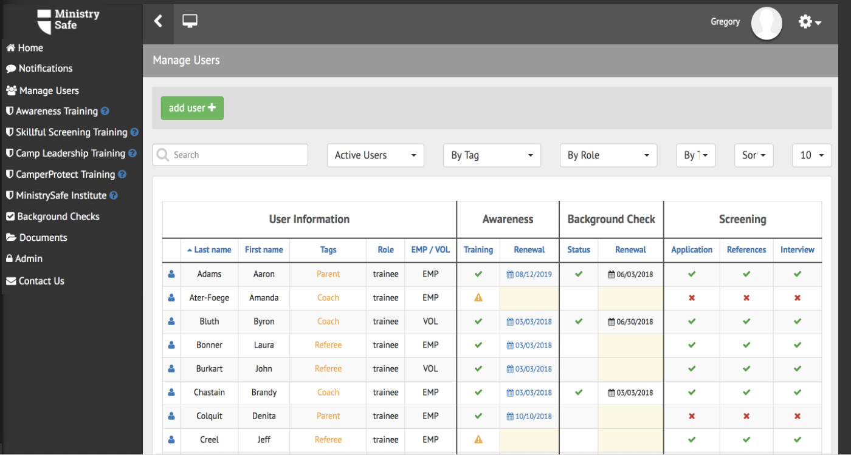

SUMMARY
The BSA litigation provides a good opportunity for all child-serving organizations to look closely at child sexual abuse risk and third-party use of facilities. Where facilities use is concerned, good analysis, forms and record-keeping are important – the alternative creates unnecessary liability. Generosity is a virtue, but organizational leaders must understand that, in some circumstances, an organization’s primary mission may be threatened by inartful or haphazard use of facilities by others. More importantly, children may be harmed. To protect children and missional goals, leaders must understand sexual abuse risk and sexual abuse risk management.

The Facilities Use Fire Drill provides an avenue for evaluating facilities use while creating a framework that raises the bar for child safety and ensures insurance coverage in the event of an injury.

Learn more about MinistrySafe and Abuse Prevention Systems.
______________________________________________________________________________

Kimberlee Norris and Gregory Love are partners in the Fort Worth, Texas law firm of Love & Norris and founders of MinistrySafe and Abuse Prevention Systems providing child sexual abuse expertise to child-serving organizations worldwide. After representing victims of child sexual abuse for more than two decades, Love and Norris saw recurring, predictable patterns in predatory behavior. MinistrySafe/Abuse Prevention Systems grew out of their desire to place proactive tools into the hands of child-serving professionals.

Love and Norris teach the only graduate-level course on Preventing Sexual Abuse in Ministry Contexts as Visiting Faculty at Dallas Theological Seminary.

